ABSTRACT
Some wise scientist once said that control system is a system where we can shut down the machine whenever we want. That's the difference between controlled and uncontrolled machine. Our project is about make this control system efficient and dynamic. As the name suggested the automatic control is for controlling the motor from remote place, look over its operating conditions, get feedback from the motor itself. Our target is to control the motor from distant place by mobile DTMF tone and also get feedback by SMS while it is in ON or OFF condition. We also ensure the safe operation of the motor by detecting the voltage of the source and ensure feedback from system while it is over or under voltage. Again, we also get these feedbacks by SMS as well. GSM network is everywhere in our country that's why we choose GSM network to operate our motor also transfer feedback information through it. We also use GSM network because if we use it then we don't need to establish extra equipment for networking. To transmit feedback signals we use GSM modem at the motor end also generate control signal by mobile DTMF because it is very easy to generate DTMF by mobile station and send feedback SMS by Modem as well. In industrial sector we hope our project is become handy and cost effective to operate motor and give its protection.

INDEX

Chapter No. | Contents | Page No.
1 | Introduction | 2  2-4
2 | Literature Survey | 5  6-7
3 | Scope and limitations | 8-9
4 | Methodology | 10-12
5 | Details of Design, Working, and progress  - Components use for the system  - Estimated Cost of the required components  - Working and Process | 13  14-23  24-24  25-26
6 | Field of applications of GSM based motor control | 27-28

7 | Conclusion and Future scope | 29-30
 | 7.1 Summary and conclusion | 29-30
 | 7.2 Future Scope | 29-30

8 | Appendix  8.1 Datasheets | 31  31
9 | References and bibliography | 72-73

Chapter 1 INTRODUCTION

Introduction

In today’s fast changing world, everything is becoming compact, portable and mobile. The mobile handsets for communication are the biggest advancement in the area, these have made our lives much simpler and connected. Today almost everyone is familiar with its usage, and is able to draw advantage from it.
India is basically an agricultural country, and all its resources depend on the agricultural output. Even in the modern span of industrialization, agriculture is the key area that decides the economic growth of the country. Agriculture also accounts for 8.56% 0f the countries total exports. Agriculture is the most important field has compared to others in India the underground water level is slowly falling down and as well as rainfall is also reduced due to deforestation. In order to get the maximum yield in agricultural process, it is necessary to supply the optimum quantity of water and it should be supplied periodically. This is achieved only through a systematic irrigation system. Irrigation is the science of planning and designing an efficient, low-cost, economic irrigation system designed in such a way to fit natural conditions. By the construction of proper distribution system and providing of adequate water supply will increase the yield of crops.
The major problem was senior citizens in rural area weren’t knowledgeable enough to send a text SMS. But they were knowledgeable enough to make calls and recognize whether the call is “not reachable” or “out of range” or “subscriber is busy” or the other party picked up their call.
We will be constructing an Arduino based circuit which can trigger a relay with a call. The call will be terminated after a couple of rings automatically and gives out an acknowledgement SMS back to the owner’s phone. Making a call to the circuit rather than a text SMS will cut down the network service cost by half.
Calling to GSM module will cost you nothing, but the acknowledgement SMS back from the GSM module might cost you.
The system will respond only to the owner’s mobile phone number. Any calls from any other number will be rejected.

Project Objectives

This project aims in providing a user friendly, reliable and automated 3- phase water pump control system for farmers. Here the automation process is done through the wireless GSM technology
The main objective of this project is to control the motor. Control means ability to shut down a machine whenever we want to and in this project it is done with wireless signal transmission. Our objective is to give the motor proper protection. We have tried to simplify this system / project as much as possible to make it easy for everyone, from beginners to expert.

Problem overview

You might have noticed that in most of the cases the crop-fields are located far away from the farmer's residence. Farmers have to travel significant distances to go to their crop fields.
Irrigation is an essential part of farming. As we know, it needs to be done daily, and due to this fact, whatever may be the distance between farm and home, the farmer has to go to their crop fields every day to turn on the irrigation system and supply water to crops.
There are two cons of this daily travel to crop fields, waste of both time and money.
So, we felt like traveling is not a viable option when it can be done remotely. With GSM based agriculture motor control it's that simple; sitting at home, clicking a button on your smartphone and controlling motors!

Report Outline

The report consists of chapters outlined below. These chapters are discussed in brief in this section. Chapter 2 Reviews the literature related to GSM BASED MOTOR CONTROL

Chapter 3 gives detailed information about the scope and limitation

Chapter 4 gives detailed information on the proposed methodology and modifications done here.

Chapter 5 gives a detailed account of the components used, implementation techniques in both the hardware and software aspects, testing, and assembly of the system.
Chapter 6 gives a detailed insight into the results achieved and the application of the GSM BASED MOTOR CONTROL.
Chapter 7 presents the conclusion and summary of the report and covers all the references.

Chapter 2 LITERATURE SURVEY

  - Literature survey

Technological development is the forefront of today’s scientific world. Everyday some new products have been launched with various features. A simple mobile phone can perform huge and complex nowadays. People want to perform all the tasks just by pressing some keys and buttons. GSM based motor control is also the result of the advancement in technology.
Many research has been done in the agriculture field, most of them are concentrating on sensors parameters and automatic switching mechanisms of pumps based on sensor’s
signals. The literature review shows that, with the wide spread use of cellular networks, automatic irrigation systems have been applied through wireless technology at the farm area incorporating GSM technology with mobile phone through the mobile network. The technology is one of the factors which limit the implementation of some of the automated irrigation system in developing countries

Work related to GSM Based Motor Control

Agriculture is one of biggest industry in India which serves food for more than a billion people every year. Producing vast amount of food is never an easy task; irrigation is one of the factor.
The improvement is all about the revert acknowledgement, where the user will receive a SMS response in his cellphone from the GSM pump controller system when a user sends a valid SMS comment.
The existing design sends an acknowledgement SMS to the user independent of the actual state of the relay i.e., ON/OFF.
The new design change suggested by Mr. Gandhi checks the state of the relay whether the relay is physically switched its state or not.
The change as per this new GSM water pump controller design can be implemented to the previous design without much hassle by adding a feedback system as shown in the schematic and uploading the new code.
When we send SMS command “/MOTOR ON/” the pin # 9 goes high and trigger the relay ON. If the relay connects the common and N/O pins the pump starts and also turns ON the transformer which will give +5 at the output.
The +5V signal is fed to pin # 7 which will confirm and return with an acknowledgement “Motor

activated”.
When we send “/MOTOR OFF/” the pin # 9 turns LOW and relay disconnects the common and N/O pins, this will turn off the pump as well as the connected transformer. The output at pin # 7 goes LOW and returns with an acknowledgement “Motor deactivated”.
If no acknowledgement SMS is received in your cellphone, we can confirm that no action was taken and the pump is at the last requested state, you may go to the site and troubleshoot or no acknowledgement is received due power.

Chapter 3

SCOPE AND LIMITATIONS

Scope and limitations

This system mainly developed to the farmers, but it also used in industry area. In the industrial area for three phase motor protection gives through this system. This is best example of the embedded system. Any automation is provided through this system. In that microcontroller use to control the overall operations and as per our requirement we change the controller operation. The motor is switch on/off to give a missed call. This helps to reduce the labor cost and maintain the proper timing of water. We get the all condition of the motor from any place. It also very useful to industry area to control the motors. Result in this system we done to give the protection to three phase motor against the over voltage, over current, single phasing & dry run. We switch on/off the motor by sending the message to the system. Any abnormal condition is occurring the system switch off the motor automatically and intimate the fault to user.

Chapter 4 Methodology

Methodology
Agriculture is one of the fields where technological development is slow.

This SMS based GSM motor controller takes a little step towards agricultural development, this may not be a revolutionary project but, it may bring delight among agriculturists.

Let’s dive into technical part of the project.

The project is designed with minimal hardware components so that a beginner can accomplish it with ease.
The circuit consists of power supply, which powers the whole setup.
The Arduino is the brain of the project which take decisions and GSM modem which sends and receives text SMS and communicate with the user and relay which controls the motor.
The transformer step down the 230VAC to 12VAC and bridge rectifier convert AC onto DC current and the current passes through an electrolytic capacitor to smooth the power supply.
A fixed 12V voltage regulator gives power to Arduino, GSM modem and relay. The GSM modem is connected to Arduino at pin #0 and pin #1, which are RX and TX respectively.
The RX of GSM is connected to TX of Arduino and TX of GSM is connected to RX of Arduino. If you are confused, just look at the below diagram, misconnection will not send or receive SMS.

ARDUINO TX----------------------RX GSM modem RX TX

Ground to ground connection is also established between Arduino and GSM modem.Try to get a male jack power connector for the GSM and Arduino, if not just solder the wires directly from power supply to Arduino and GSM, which might increase the mess in the project.

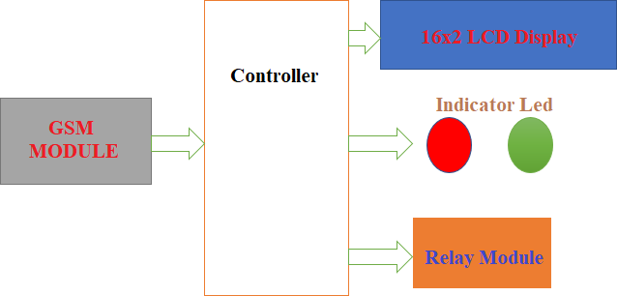

Figure 4.1: Block diagram of Gas Leakage Detector

Chapter 5

DETAILS OF DESIGN AND WORKING PROCESS

Components used for the system
- Dc Water Pump

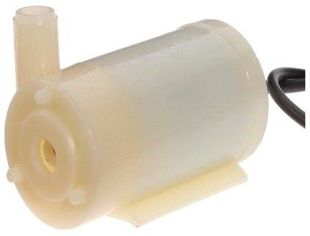

Figure5.1 Dc Water Pump
Micro DC 3-6V Micro Submersible Pump Mini water pump For Fountain Garden Mini water circulation System DIY project. This is a low cost, small size Submersible Pump Motor which can be operated from a 3
- 6V power supply. It can take up to 120 liters per hour with very low current consumption of 220mA. Just connect tube pipe to the motor outlet, submerge it in water and power it. Make sure that the water level is always higher than the motor. Dry run may damage the motor due to heating and it will also produce noise.

Specifications:

  - Operating Voltage: 3 ~ 6V
  - Operating Current: 130 ~ 220mA
  - Flow Rate: 80 ~ 120 L/H
  - Maximum Lift: 40 ~ 110 mm
  - Continuous Working Life: 500 hours
  - Driving Mode: DC, Magnetic Driving
  - Material: Engineering Plastic
  - Outlet Outside Diameter: 7.5 mm

Arduino Nano

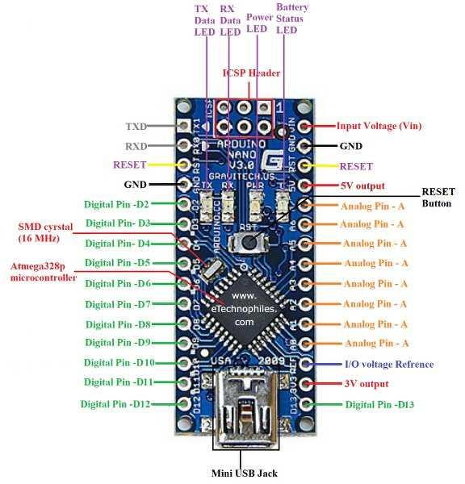
Figure 5.2: Arduino Nano

Arduino Nano is a small, complete, flexible and breadboard-friendly Microcontroller board, based on ATmega328p, developed by Arduino.cc in Italy in 2008 and contains 30 male I/O headers, configured in a DIP30 style.
Arduino Nano Pinout contains 14 digital pins, 8 analog Pins, 2 Reset Pins & 6 Power Pins. It is programmed using Arduino IDE, which can be downloaded from Arduino Official site.
Arduino Nano is simply a smaller version of Arduino UNO, thus both have almost the same functionalities. It comes with an operating voltage of 5V; however, the input voltage can vary from 7 to 12V.
Arduino Nano’s maximum current rating is 40mA, so the load attached to its pins shouldn’t draw current more than that.
Each of these Digital & Analog Pins is assigned with multiple functions but their main function is to be

configured as Input/Output.
Arduino Pins are acted as Input Pins when they are interfaced with sensors, but if you are driving some load then we need to use them as an Output Pin.
Functions like pin Mode and digital Write are used to control the operations of digital pins while analog Read() is used to control analog pins.
The analog pins come with a total resolution of 10-bits which measures the value from 0 to 5V.
Arduino Nano comes with a crystal oscillator of frequency 16 MHz. It is used to produce a clock of precise frequency using constant voltage.
There is one limitation of using Arduino Nano i.e., it doesn’t come with a DC power jack, which means you can not supply an external power source through a battery.
This board doesn’t use standard USB for connection with a computer, instead, it comes with Type-B Micro USB.
The tiny size and breadboard-friendly nature make this device an ideal choice for most applications where the size of the electronic components is of great concern.
Flash memory is 16KB or 32KB that all depends on the Atmega board i.e. Atmega168 comes with 16KB of flash memory while Atmega328 comes with a flash memory of 32KB. Flash memory is used for storing code. The 2KB of memory out of total flash memory is used for a bootloader.
The SRAM memory of 2KB is present in Arduino Nano. Arduino Nano has an EEPROM memory of 1KB.

Liquid Crystal Display (LCD)
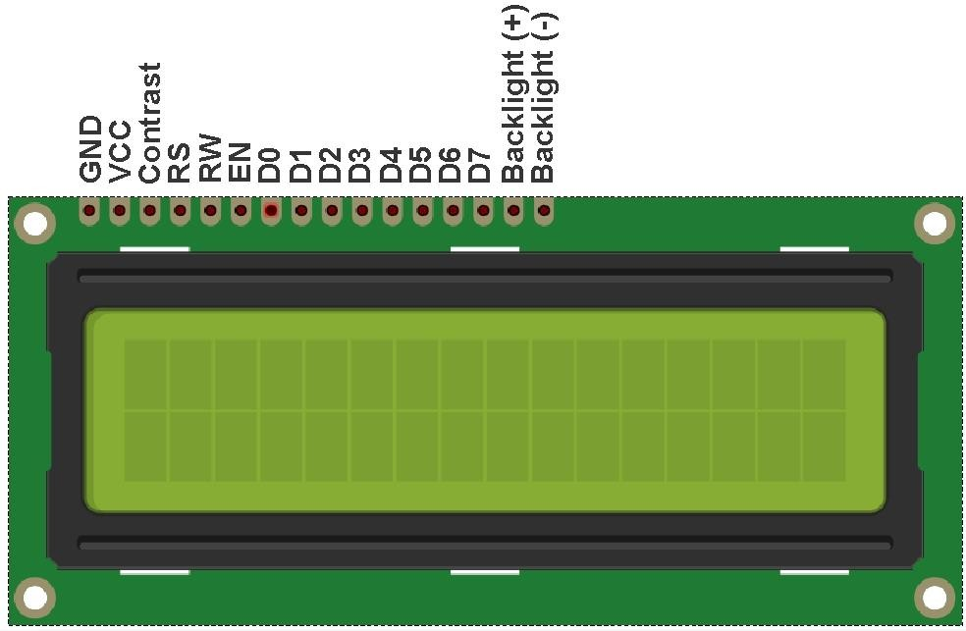
Figure 5.3: Liquid Crystal Display (LCD)

What is the LCD 16×2?

The term LCD stands for liquid crystal display. It is one kind of electronic display module used in an extensive range of applications like various circuits & devices like mobile phones, calculators, computers, TV sets, etc. These displays are mainly preferred for multi-segment light-emitting diodes and seven segments. The main benefits of using this module are inexpensive; simply programmable, animations, and there are no limitations for displaying custom characters, special and even animations, etc.

This is LCD 1602 Parallel LCD Display that provides a simple and cost-effective solution for adding a 16×2 White on Liquid Crystal Display into your project. The display is 16 character by 2 line display has a very clear and high contrast white text upon a blue background/backlight.
This is great blue backlight LCD display. It is fantastic for Arduino based project. This LCD1602 LCD Display is very easy to interface with Arduino or Other Microcontrollers.
This display overcomes the drawback of LCD 1602 Parallel LCD Display in which you’ll waste about 8 Pins on your Arduino for the display to get working. Luckily in this product, an I2C adapter is directly soldered

right onto the pins of the display. So all you need to connect are the I2C pins, which show a good library and little of coding.
The I2C is a type of serial bus developed by Philips, which uses two bidirectional lines, called SDA (Serial Data Line) and SCL (Serial Clock Line). Both must be connected via pulled-up resistors. The usage voltages are standard as 5V and 3.3V.
If you already have the I2C adapter soldered onto the board like in this product, the wiring is quite easy. You should usually have only four pins to hook up. VCC and GND of course. The LCD display works with 5 Volts. So we go for the 5V Pin.
The values shown on the display can be either a simple text or numerical values read by the sensors, such as temperature or pressure, or even the number of cycles that the Arduino is performing.

Specifications & Features: -

- Arduino IIC/I2C interface was developed to reduce the IO port usage on Arduino board
- I2C adapter allows flexibility in connections
- I2C Reduces the overall wirings.
- 16 characters wide, 2 rows

- White text on the blue background

- Single LED backlight included can be dimmed easily with a resistor or PWM.

- Interface: I2C

- Interface Address: 0x27

- Character Color: White

- Backlight: Blue

- Supply voltage: 5V

GSM SIM900A MODULE

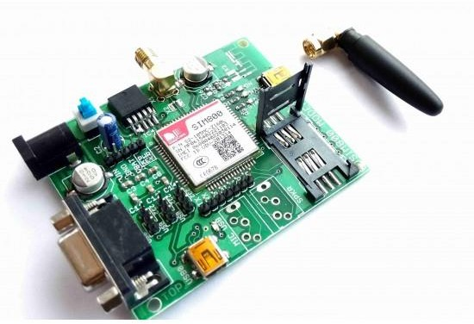

Figure 5.5: GSM SIM800A MODULE

The main purpose of our smartphone/cellular phone is to receive and make calls and send SMS, this task is achieved by GSM/GPRS module integrated into the device.

GSM module is a specialized type of modem which accepts a SIM card, and operates over a subscription to a mobile operator, just like a mobile phone.

The SIM800A Quad-Band GSM/GPRS Module with RS232 Interface is a complete Quad-band GSM/GPRS solution in an LGA(Land grid array) type which can be embedded in the customer applications. SIM800A support Quad-band 850/900/1800/1900 MHz, it can transmit Voice, SMS and data information with low power consumption.
With a tiny size, it can fit into slim and compact demands of custom design. Featuring and Embedded AT, it allows total cost savings and fast time-to-market for customer applications.
The SIM800A modem has a SIM800A GSM chip and RS232 interface while enables easy connection with the computer or laptop using the USB to the Serial connector or to the micro-controller using the RS232 to

TTL converter. Once you connect the SIM800A modem using the USB to RS232 connector, you need to find the correct COM port from the Device Manager of the USB to Serial Adapter.
Then you can open Putty or any other terminal software and open a connection to that COM port at 9600 baud rate, which is the default baud rate of this modem. Once a serial connection is open through the computer or your micro-controller you can start sending the AT commands. When you send AT commands for example “AT\r” you should receive back a reply from the SIM800A modem saying “OK” or other response depending on the command sent.

Features and Specifications of SIM800A Module:

- SIM800A Quad Band GSM Module
- Bands: GSM 850MHz, EGSM 900MHz, DCS 1800MHz, PCS 1900MHz
- Coding schemes: CS-1, CS-2, CS-3, CS-4 Tx power: Class 4 (2W), Class 1 (1W)
- GPRS class 2/10.
- Control via AT commands (3GPP TS 27.007, 27.005 and SIMCOM enhanced AT command set).
- Voltage Supply Required- 9VDC to 12VDC with at least 2A Peak Current Capability
- High-Quality Product (Not hobby grade).
- 5V interface for direct communication with MCU kit.
- TTL Rx and TTL Tx and DB9 Connector Based RS232 Outputs
- Configurable baud rate
- Built-in SIM Card holder.

Applications :-

- Remote Data Monitor and Control.
- Water, gas and oil flow metering.
- AMR (automatic meter reading).
- Power station monitoring and control.
- Remote POS (point of sale) terminals.
- Traffic signals monitor and control.
- Fleet management.
- Power distribution network supervision.

- 5V Relay Channel
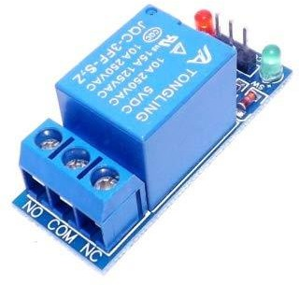
Figure 5.5: 5V Relay Channel
This is 1 Channel 5V Relay Board Module For Arduino PIC AVR DSP ARM. A wide range of microcontrollers such as Arduino, AVR, PIC, ARM and so on can control it. Each one needs 15mA - 20mA driver current and Equipped with high current relay: DC 5V / 10A, AC 250V / 10AStandard interface that can be compatible with microcontroller.

Specification and Features:

  - 1 channel relay board
  - Operating Voltage 5V
  - Max Current : 20mA
  - Relay Contact Current Capacity at AC250V: 10A
  - Relay Contact Current Capacity at DC5V: 10A
  - One normally closed contact and one normally open contact
  - Triode drive, increasing relay coil
  - High impedance controller pin
  - Pull-down circuit for avoidance of malfunction
  - Power supply indicator lam
  - Control indicator lamp
  - Indicator for Relay output status
  - Can Be controlled various appliances & other Equipment With Large current.
  - Standard TTL Level logic controlled (AVR, Arduino, 8051, PIC, ARM)

V. Jumper Wires

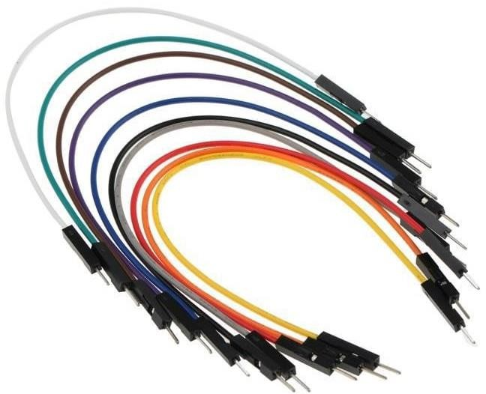

Figure 5.6 Jumper Wires

A jump wire (also known as jumper, jumper wire, jumper cable, DuPont wire, or cable) is an electrical wire, or group of them in a cable, with a connector or pin at each end (or sometimes without them – simply "tinned"), which is normally used to interconnect the components of a breadboard or other prototype or test circuit, internally or with other equipment or components, without soldering. Individual jumper wires are fitted by inserting their "end connectors" into the slots provided in a breadboard, the header connector of a circuit board, or a piece of test equipment.

VI. 12 Volt Adapter
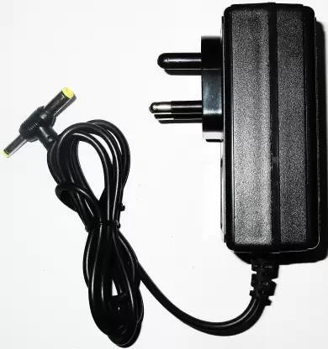
Figure 5.8: 12V Adapter
12 Volt 2 Amp Power Adapter takes an AC INPUT of 100-240V and gives 12V 2A DC output

Features:-
- Excellent Quality
- Short Circuit, Over Voltage & Over Current Protection
- Incredibly Low Fault Rates
- No Minimum Load
- This power supply is a regulated Center Positive power supply
- It's plug design is for Indian power socket so, no plug converter is required
- Compact size & light weight
- High Reliability
- Regulated Stable Voltage
- Good quality SMPS Based Adapter
- Stabilized Output, low ripple & low interference
- Single Output Voltage
- High Efficiency & low energy consumption

